
359

EKEM4D

Installation and operation instruction T1.2

ZHEJIANG ETEK ELECTRICAL TECHNOLOGY CO.,LTD.

Declaration

The copyright is the property of ETEK. Any information in any paragraph or section cannot be extracted, copied or otherwise reproduced or propagated. Otherwise offenders shall take all consequences.
All rights are reserved.

ETEK reserves the right to modify the product specifications herein without notification. Please consult the local agent about the latest specifications before placing a purchase order.
Manual revision record
Data | Old | New | Change
2022.05.17 |  | T1.0 | 1.First version
2022.08.19 | T1.0 | T1.1 | 2.Add direct access model
2023.02.08 | T1.1 | T1.2 | 3.Add Device model register

content
1 General - 1 -
2 Function description - 1 -
3 Technical parameter - 2 -
4 Outline - 3 -
5 Wiring and installing - 3 -
6 Function description - 5 -
7 Operation and display - 6 -
8 Communication description - 11 -

1 General
EKEM4D is a smart meter designed for power supply system, industrial and mining enterprises and utilities to calculate the electricity consumption and manage the electric demand. It features the high precision, small size and simple installation. It integrates the measurement of all electrical parameters with the comprehensive electricity metering and management provides various data on previous 48 months, checks the 31st harmonic content and the total harmonic content. It is fitted with RS485 communication port and adapted to MODBUS-RTU .EKEM4D can be used in all kinds of control systems, SCADA systems and energy management systems. The meter meet the related technical requirements of electricity meter in the IEC62053-21standards.

2 Function description
Table 1 Function description list
Function | Function description | Function provide
Measurement of kWh | Active kWh (positive and negative) | ■
Measurement of kWh | Reactive kWh (positive and negative) | ■
Measurement of kWh | A. B, C split phase positive active energy | ■
Measurement of electrical parameters | U、I | ■
Measurement of electrical parameters | P、Q、S、PF、F | ■
Measurement of harmonics | 2~31ST Voltage and current harmonic | ■
LCD Display | 12 bits section LCD display, background light | ■
Key programming | 3 keys to communication and set parameters | ■
Pulse output | Active pulse output | ■
Multi-tariff and functions | Date, time | □
Multi-tariff and functions | Max demand and occurrence time | □
Multi-tariff and functions | Frozen data on last 48 months, last 90days | □
Multi-tariff and functions | Adapt 4 time zones, 2 time interval lists, 14 time interval by day and 4 tariff rates | □
Communication | Communication interface: RS485, Communication protocol: MODBUS-RTU | ■

3 Technical parameter
Table 2 technical parameter descriptions
project |  |  | performance parameter
Specification |  |  | 3 phase 3 wires | 3 phase 4 wires
Measurement | Voltage | Reference voltage | 3×100V, 3×400V | 3×57.7/100V, 3×230/4000V
Measurement | Voltage | Voltage Range | 3×100V~3×450V | 3×57.7/100V~3×260/450V
Measurement | Voltage | Consumption | <10VA(Single phase)
Measurement | Voltage | Impedance | >2MΩ
Measurement | Voltage | Accuracy class | Error±0.2%
Measurement | Current | Input current | 0.01-1(6)A (Secondary access model)  0.5-10(80)A(Direct access model)
Measurement | Current | Consumption | <1VA Single phase rated current
Measurement | Current | Accuracy class | Error±0.2%
Measurement | Power |  | Active, reactive, apparent power, error±0.5℅
Measurement | Frequency |  | 45～65Hz，Error±0.2%
Mete  ring | Active Energy Class(kWh) |  | C(kWh)
Mete  ring | Clock |  | ≤0.5s/d
Digit signal | Energy pulse output |  | 1 active photocoupler output
pulse | Width of pulse |  | 80±20ms
pulse | Pulse constant |  | 10000imp/kWh
communication | Interface and communication protocol |  | RS485：Modbus RTU
communication | Range of communication address |  | Modbus RTU:1~ 247；
communication | Baud rate |  | 1200bps~38400bps
envir-onment | working temperature |  | -25℃ to +55℃
envir-onment | Relative humidity |  | ≤95℅(No condensation)

4 Dimension drawings
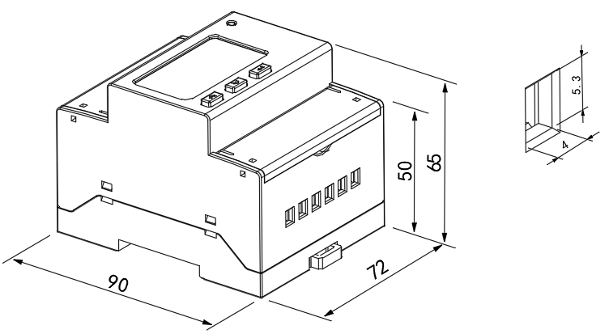
Fig 1 connect via CT
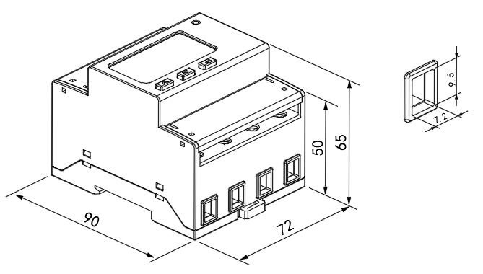
Fig 2 direct connect
Note：The torque of direct connect should not be greater than 3-4N·m，and the torque of connect via CT should not be greater than 1.5-2N·m。

5 Wiring and installing

5.1 Wiring sample of voltage and current
Fig 3 Three phase four lines connect via CT

Fig 4 Three phase three lines connect via CT
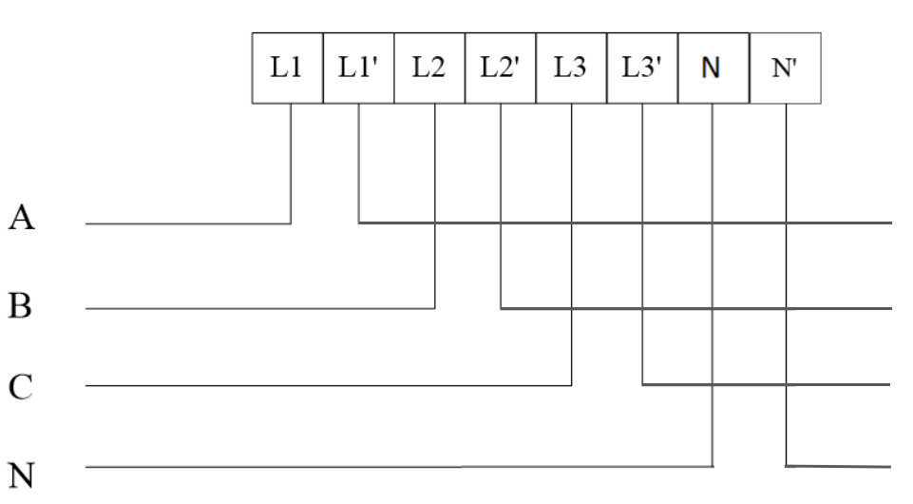
Fig 5 Three phase four lines direct connect
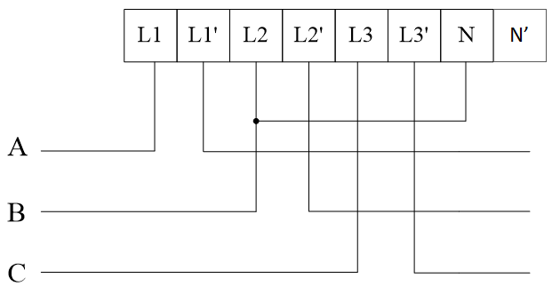
Fig 6 Three phase three lines direct connect
Note：The default current for the direct access model flows from the top in and out from below and can be changed to the opposite direction.

5.2 Wiring diagram of communication and pulse terminals
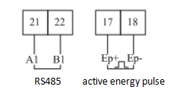
Fig 4 Communication, pulse connection

6 Function description

6.1 Measurement
It can measure the electrical parameter,include U、I、P、Q、S、PF、F、1~31th harmonic.
Such as:U = 220.1V，f = 49.98Hz, I = 1.99A，P = 0.439kW.

6.2 Calculating
Can measure the active energy、forward active energy、reversing active energy、forward reactive energy、reversing reactive energy.

6.3 Timing
Two timing table，four time zone，one table have fourteen timing，four rate.

6.4 Demand
The description about demand:
Table 3 Demand description list
Demand | The average power in the demand cycle.
Maximum demand | The maximum value of demand in a period of time.
Slip time | A recurrence method to measure the demand from any time point during a period shorter than the demand period. The demand measured by this means is called sliding demand. The recurrence time is sliding window time.
Demand cycle | The time period between two same average value of demand.

The default demand cycle is 15 minutes, slip time is 1 minute.
The meter can measure 4 kinds of maximum demand: forward active, reversing active, inductive reactive, capacitive reactive maximum demand and the occur time.

6.5 History data statistics
The meter can record last 48 months or last 90 days history energy in each tariff.

7 Operation and display

7.1 Key function description
Table 4 Key’s function description
icon | Name | Function
 | Voltage and current, up | Check the voltage and current  Leftward and change flash in programming menu
 | Power, down | Check the power  Rightward and change the value on flash
 | Energy, enter | Check the energy  In/out programming menu  Save changes

7.2 Display menu
The meter will show the forward active energy after powering. The customers can change the information showing by pressing the keys. The menu description is listed as below:

Table 5 display descriptions
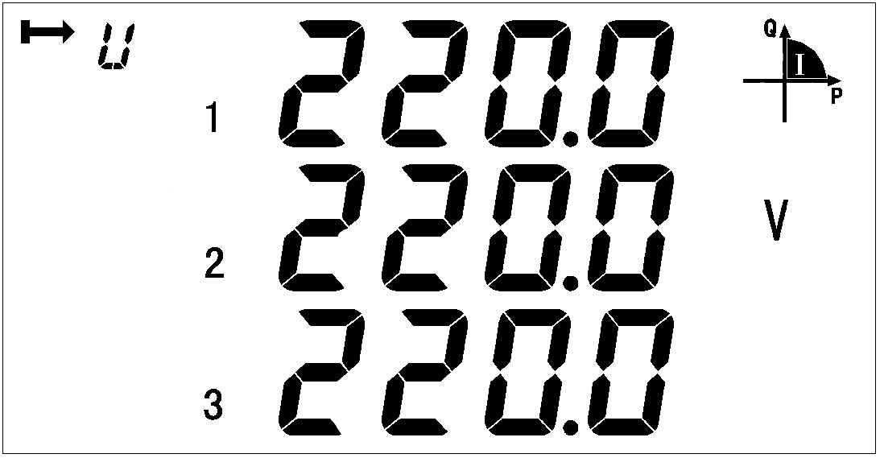
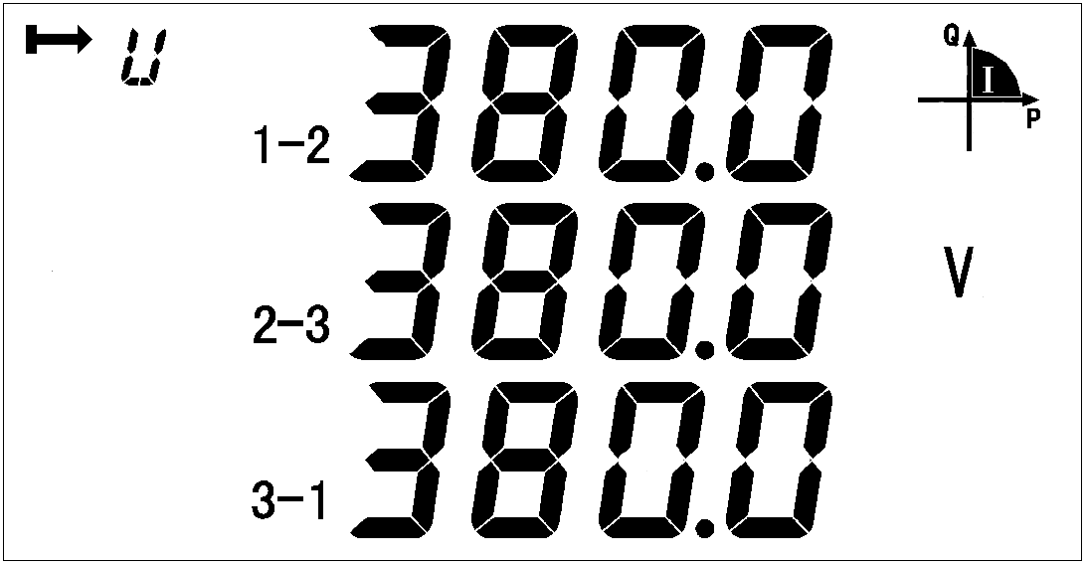
Three-phase voltage Three phase line voltage
Three-phase Current Frequency

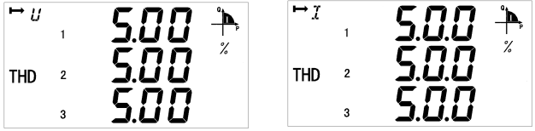
Harmonic content of three phase Harmonic content of three phase
Voltage Current
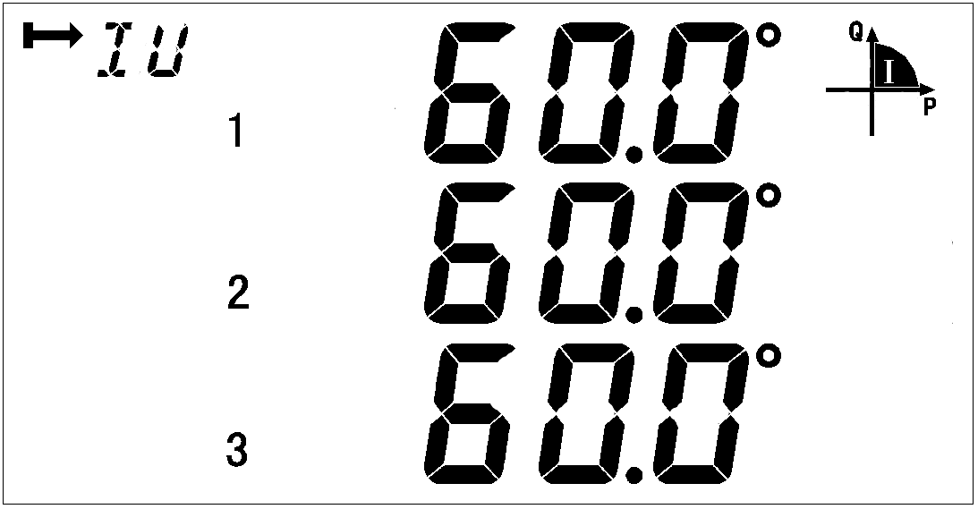
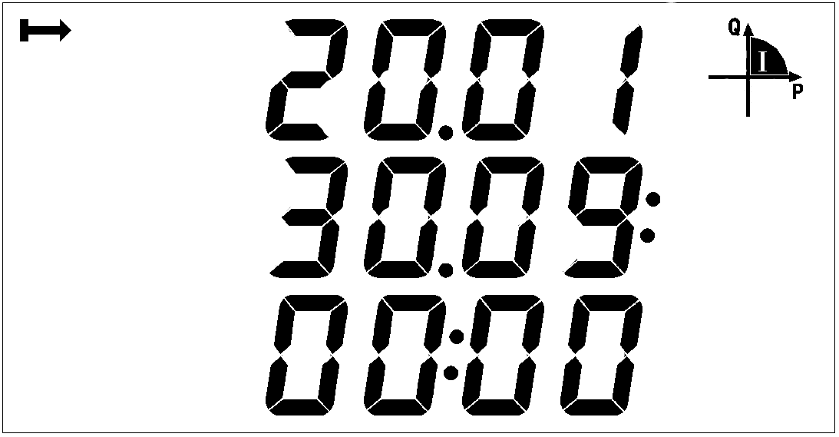
Phase angle Time
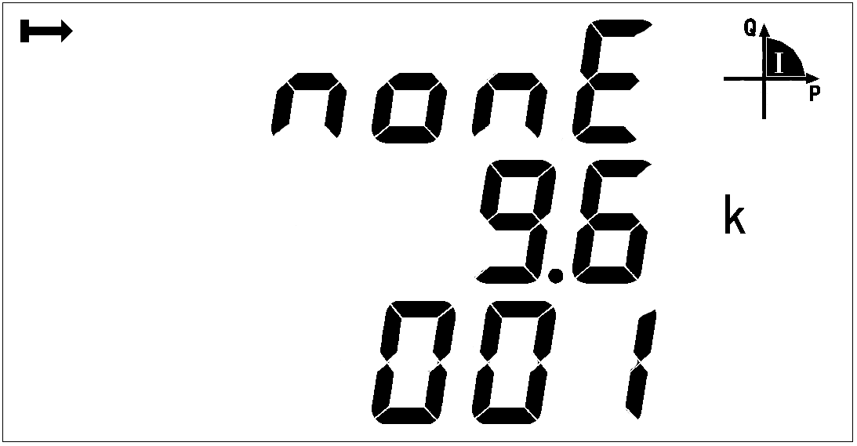

Check bit, baud rate, table address,
software version number, full display detection;
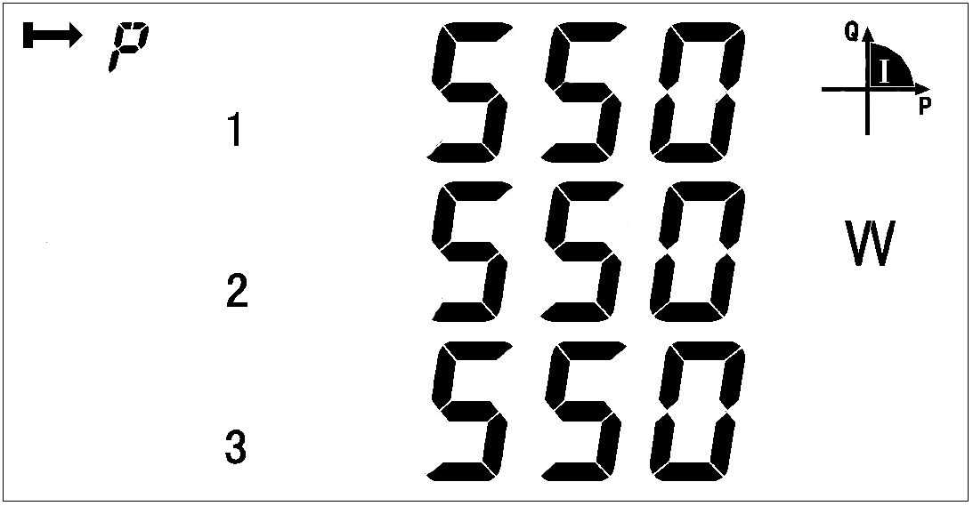
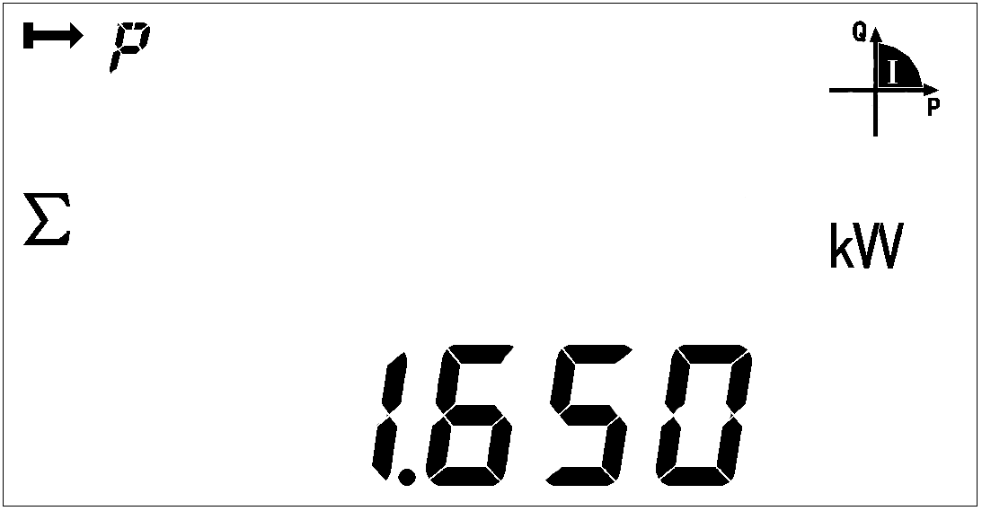

Three phase active power Total active power
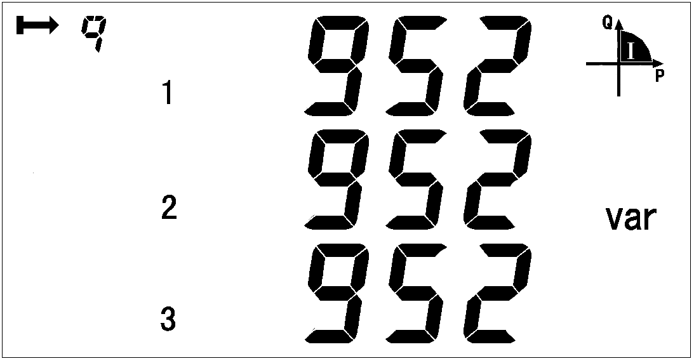
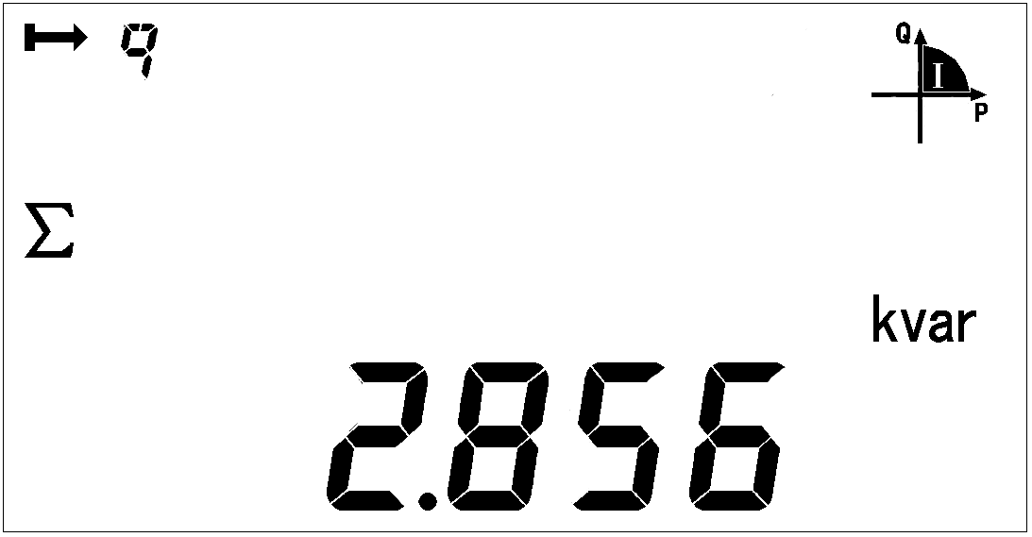

Three phase reactive power Total reactive power

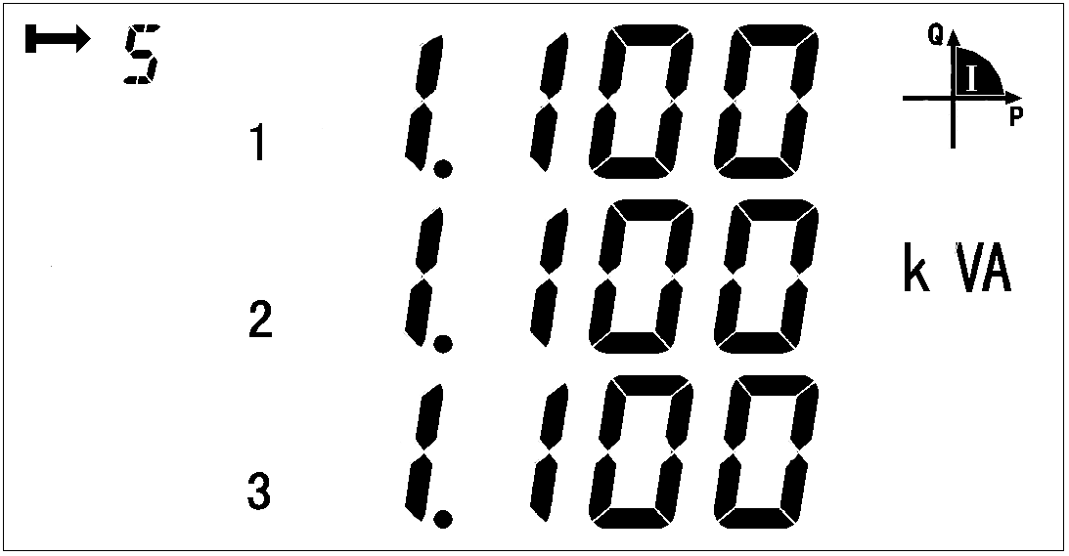
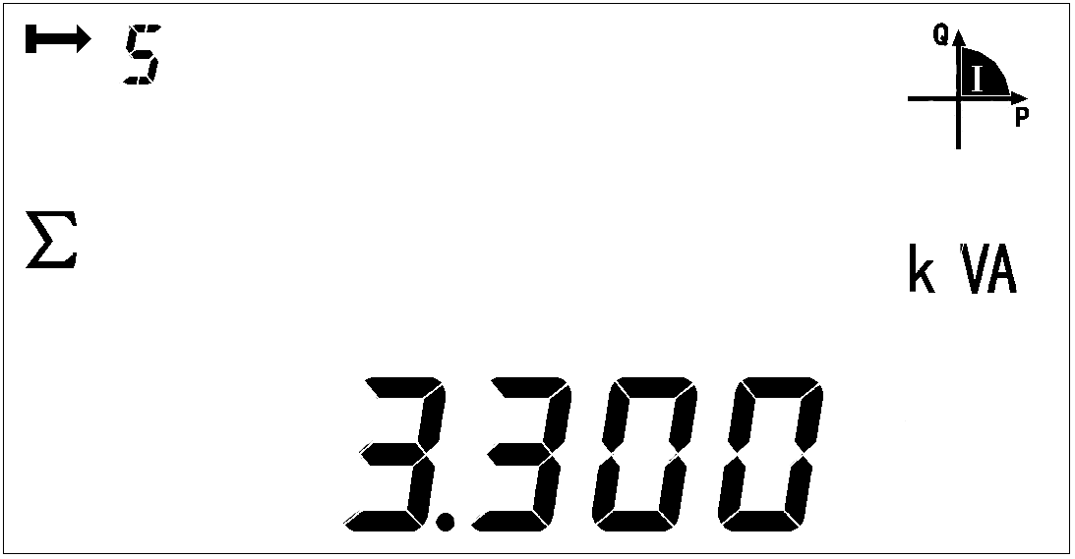

Three phase apparent power Total apparent power
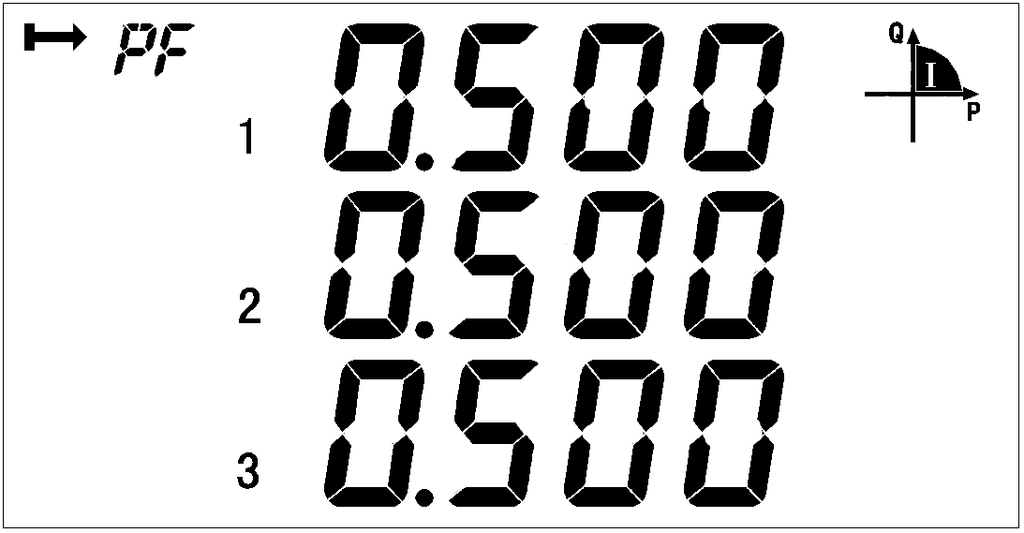
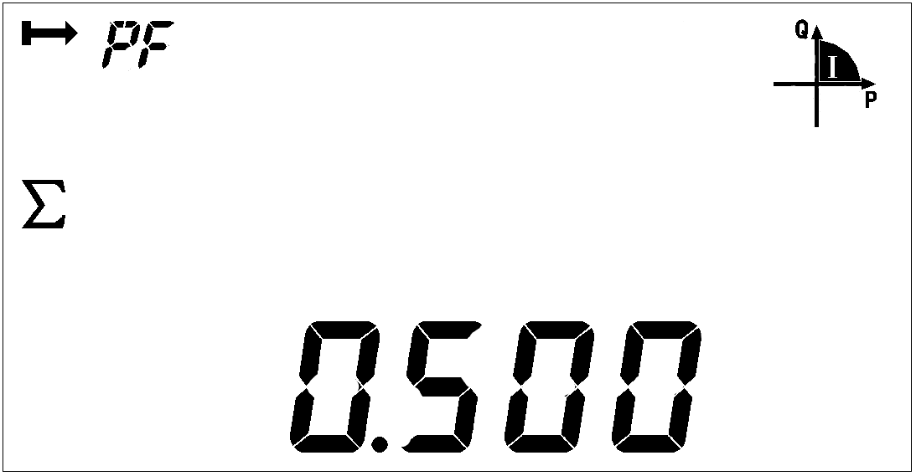

Three phase power factor Total power factor
T3 represents the normal period, ① represents the first time table
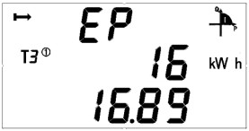
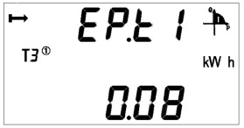
(Current value is1616.89kWh)
Current total active energy Current spike active energy
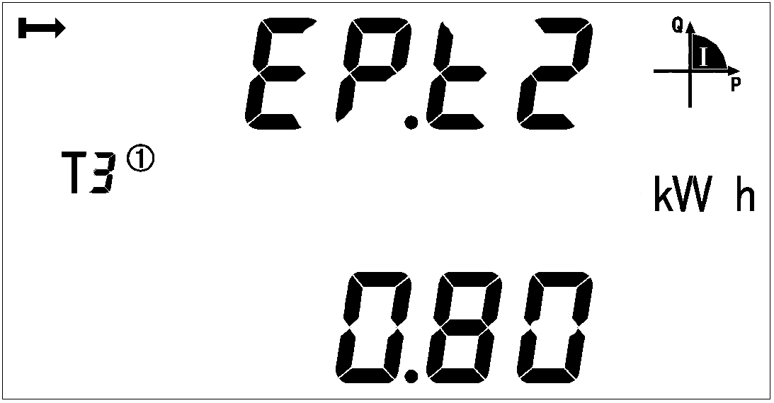
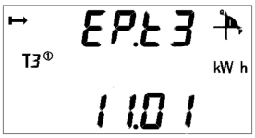

Current peak active energy Current flat active energy

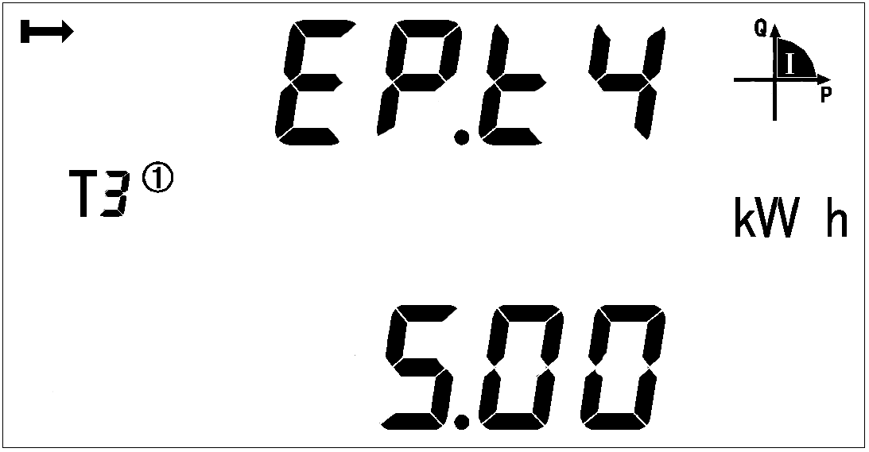
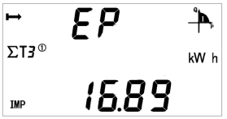

Current valley active energy Current forward active total energy
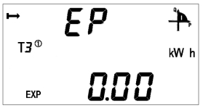
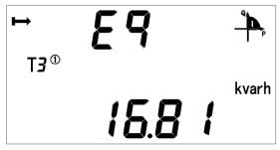

Current reversing active total energy Current total reactive energy
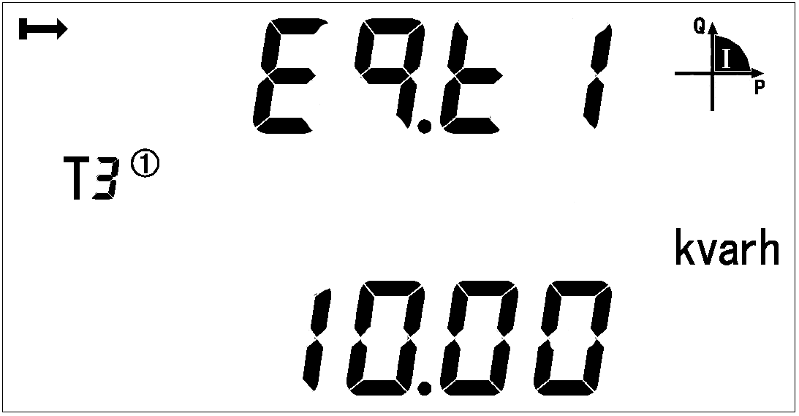
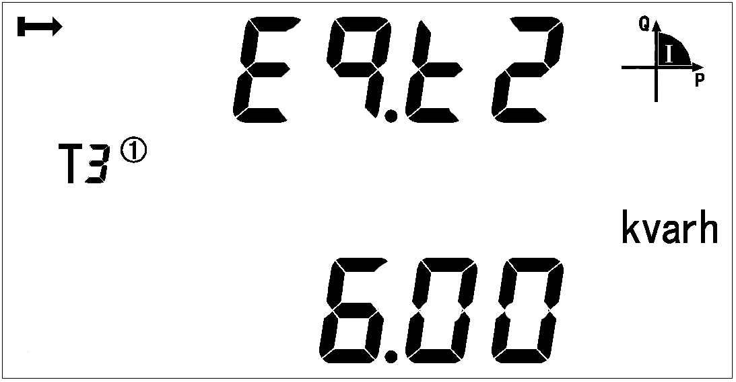
Current reactive spike energy Current reactive peak energy
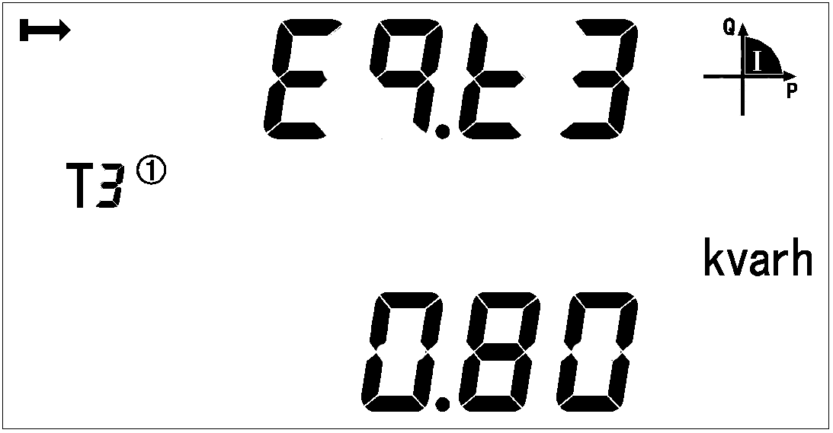
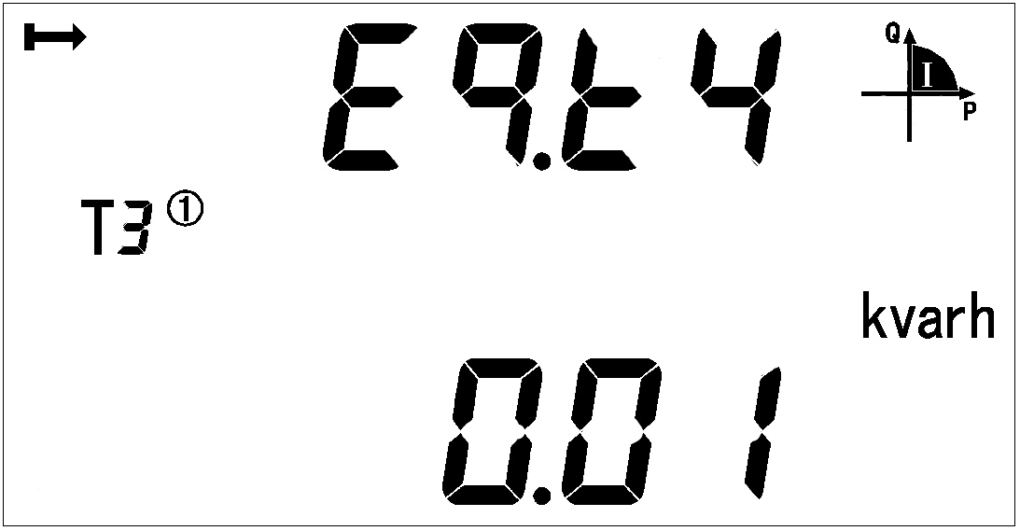

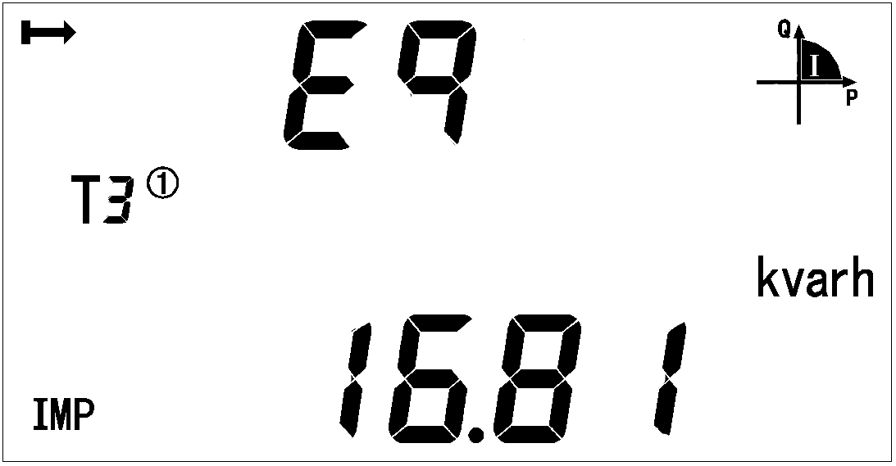
Current reactive flat energy Current reactive valley energy
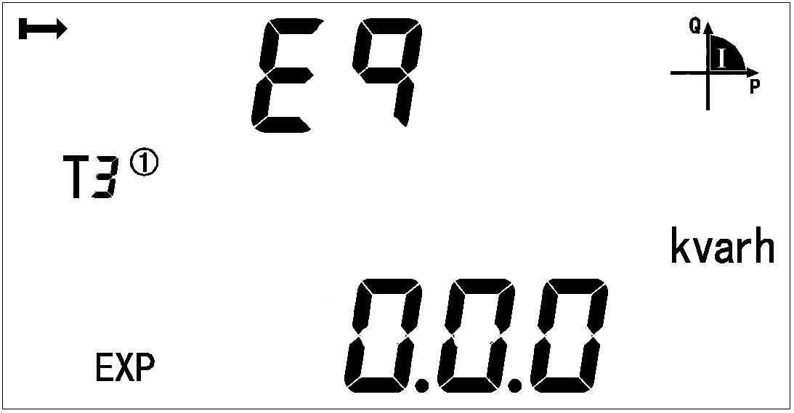

Current forward reactive total energy Current reversing reactive total energy
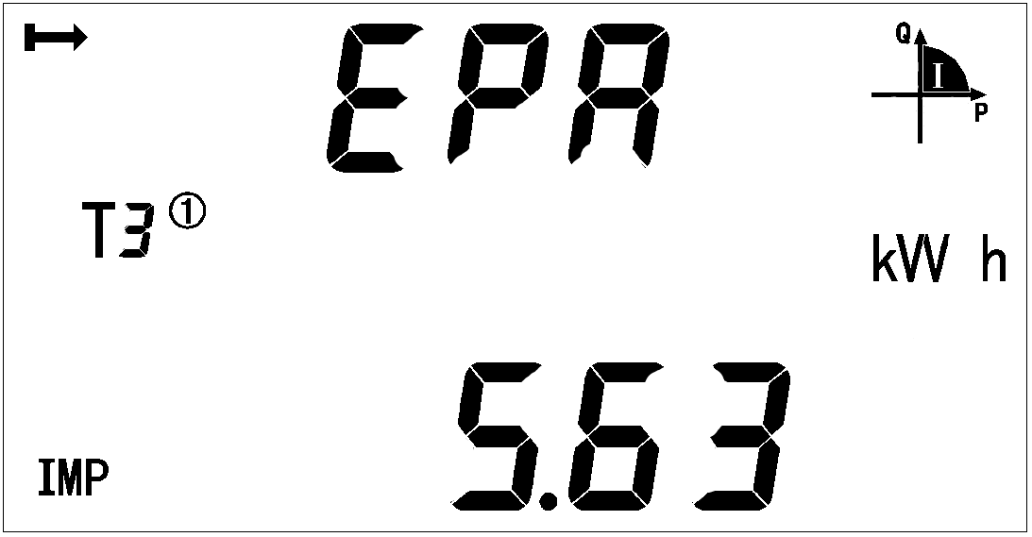
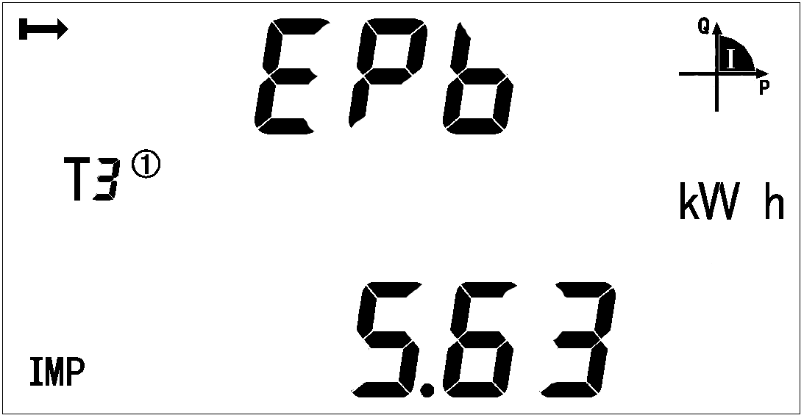

Current forward active energy Current forward active energy
on A phase on B phase
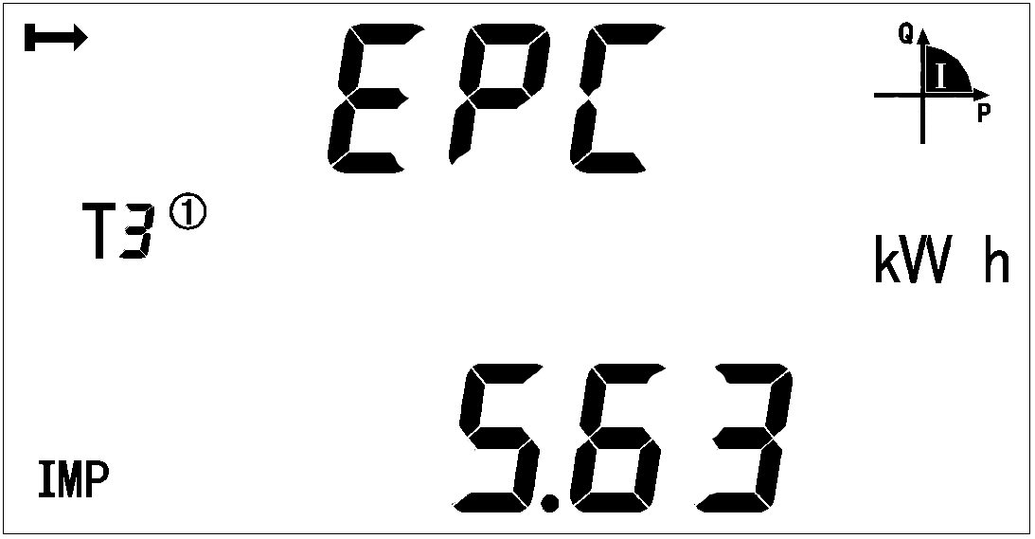

Current forward active energy on C phase
Note:
1 All the display menus above are in the model of EKEM4D three phases four lines with multi-tariff rate function and can be changed by the keys.
2 There will not be power or power factor on each phase and will only show total power and power factor (Active, reactive, apparent) under the three phase three lines.

3 There will not be date, time, maximum demand and energy by time without the function of multi-tariff rate.

7.3 Key Menu
Keep press at any main menu and get in “PASS” interface, and then press show “0000”, and enter the code. If you enter a wrong code, it will show “fail” and back to main menu; and if you enter a right code, you can set the parameter. After setting the parameter and keep press, it will show “save” and save the change by pressing in “yes” interface and quit without save by pressing in “no” interface.
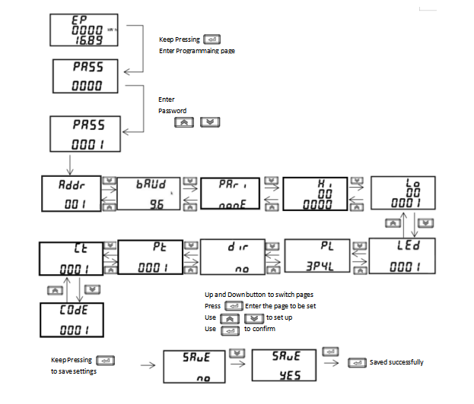7.4 Data settings
Num | Second menu
Num | Symbol | Mean | Range
1 | ADDR | Communicate’s ADDR settings | 1-247
2 | Baud | Baud choose | 1200、2400、4800、9600、19200、38400
3 | Pari | Parity choose | None、Odd、Even
4 | LED | Backlight time | 0-255minutes，more than 000 stay light-on
5 | PL | Wiring sample | 3P4L:3 phase 4 wires  3P3L:3 phase 3 wires
6 | DIR | direction of current | no-Forward  yes-Reverse
7 | S-TY | Apparent power calculation method | PQS  RMS
8 | EF-E | time-sharing measurement function | EF-Function on  E-Function off
9 | Pt | Voltage transformer settings | 1-9999
10 | Ct | Current transformer settings | 1-9999
11 | CoDE | Code settings | 1-9999
12 | PHAS | Phase angle calculation method | No-Angle between each current and each voltage  Yes-Angle between three-phase current and phase a voltage
13 | nost | Starting power shield | Shielding range:0.1-2.0%  (*UnIn)

9 Communication description

The meter adapts MODBUS-RTU protocol, and the baud rate can be chosen from 1200bps、2400 bps、4800 bps、9600bps and 19200 bps. The parity is None.
The meter needs shielded twisted pair conductors to connect. Customers should consider the whole network’s parameters such like communication wire’s length, the direction, communication transformer and network cover range, etc.

Note:
1、Wiring should follow the wiring requirements;
2、Connect all the meter in the RS485 net work even some do not need to communication, which is benefit for error checking and testing;
3、Use two color wires in connecting wires and all the A port use the same color.
4、No longer than 1200 meters of RS485 bus line.

8.1 ADDR List
MODBUS-RTU protocol has 03H and 10H command to read and write registers respectively. The following chart is registers’ address list:
Table 8 communication address list
Address | Variable | Length | R/W | Notes
0000H | Current total active energy | 4 | R | kWh  Int  Keep 2 decimal places  Particularly, if ct and Pt is not all 1, actual electric energy value should be product of register reading and Pt*ct.
0002H | Current spike active energy | 4 | R
0004H | Current peak active energy | 4 | R
0006H | Current flat active energy | 4 | R
0008H | Current valley active energy | 4 | R
000AH | Current forward active total energy | 4 | R
000CH | Current forward active spike energy | 4 | R
000EH | Current forward active peak energy | 4 | R
0010H | Current forward active flat energy | 4 | R
0012H | Current forward active valley energy | 4 | R
0014H | Current reversing active total energy | 4 | R
0016H | Current reversing active spike energy | 4 | R
0018H | Current reversing Active peak energy | 4 | R
001AH | Current reversing active flat energy | 4 | R
001CH | Current reversing Active valley energy | 4 | R
001EH | Current total reactive energy | 4 | R | kvarh  Int  Keep 2 decimal places
0020H | Current reactive spike energy | 4 | R | kvarh  Int  Keep 2 decimal places
0022H | Current reactive peak energy | 4 | R | kvarh  Int  Keep 2 decimal places
0024H | Current reactive flat energy | 4 | R | kvarh  Int  Keep 2 decimal places
0026H | Current reactive valley energy | 4 | R | kvarh  Int  Keep 2 decimal places
0028H | Current forward reactive total energy | 4 | R | kvarh  Int  Keep 2 decimal places
002AH | Current forward reactive spike energy | 4 | R | kvarh  Int  Keep 2 decimal places
002CH | Current forward reactive peak energy | 4 | R | kvarh  Int  Keep 2 decimal places
002EH | Current forward reactive flat energy | 4 | R | kvarh  Int  Keep 2 decimal places
0030H | Current forward reactive valley energy | 4 | R | kvarh  Int  Keep 2 decimal places
0032H | Current reversing reactive total energy | 4 | R | kvarh  Int  Keep 2 decimal places
0034H | Current reversing reactive spike energy | 4 | R | kvarh  Int  Keep 2 decimal places
0036H | Current reversing reactive peak energy | 4 | R | kvarh  Int  Keep 2 decimal places
0038H | Current reversing reactive flat energy | 4 | R | kvarh  Int  Keep 2 decimal places
003AH | Current reversing reactive valley energy | 4 | R | kvarh  Int  Keep 2 decimal places
003CH | Time：second、minute | 2 | R/W
003DH | Time：hour、day | 2 | R/W
003EH | Time：month、year | 2 | R/W
003FH | Address（high 8 bit）  Baud（low 8 bit） | 2 | R/W | baud：  0：1200  1：2400  2：4800  3：9600  4：19200  5：38400
0040H | pulse constant | 2 | R
0041H | First time zone address  First time zone start data:day | 2 | R/W | Time zone number：  1：First time zone  2：Second time zone  3：Third time zone  4：Fourth time zone
0042H | First time zone start data:month  Second time zone address | 2 | R/W
0043H | Second time zone start data:day  Second time zone start data:month | 2 | R/W
0044H | Third time zone address  Third time zone start data:day | 2 | R/W
0045H | Third time zone start data:month  Fourth time zone address | 2 | R/W
0046H | Fourth time zone start data:day  Fourth time zone start data:month | 2 | R/W
0047H-0060H | reserve
0061H | Voltage of A phase | 2 | R | Resolution：0.1V
0062H | Voltage of B phase | 2 | R | Resolution：0.1V
0063H | Voltage of C phase | 2 | R | Resolution：0.1V
0064H | Current of A phase | 2 | R | Resolution：0.01A
0065H | Current of B phase | 2 | R | Resolution：0.01A
0066H | Current of C phase | 2 | R | Resolution：0.01A
0067H | Active power of A phase | 2 | R | Complement form  Resolution：0.001kW
0068H | Active power of B phase | 2 | R | Complement form  Resolution：0.001kW
0069H | Active power of C phase | 2 | R | Complement form  Resolution：0.001kW
006AH | Total active power | 2 | R | Complement form  Resolution：0.001kW
006BH | Reactive power of A phase | 2 | R | Complement form  Resolution：0.001kvar
006CH | Reactive power of B phase | 2 | R | Complement form  Resolution：0.001kvar
006DH | Reactive power of C phase | 2 | R | Complement form  Resolution：0.001kvar
006EH | Total reactive power | 2 | R | Complement form  Resolution：0.001kvar
006FH | Apparent power of A phase | 2 | R | Complement form  Resolution：0.001kVA
0070H | Apparent power of B phase | 2 | R | Complement form  Resolution：0.001kVA
0071H | Apparent power of C phase | 2 | R | Complement form  Resolution：0.001kVA
0072H | Total apparent power | 2 | R | Complement form  Resolution：0.001kVA
0073H | Power factor of A phase | 2 | R | Complement form  Resolution：0.001
0074H | Power factor of B phase | 2 | R | Complement form  Resolution：0.001
0075H | Power factor of C phase | 2 | R | Complement form  Resolution：0.001
0076H | Total power factor | 2 | R | Complement form  Resolution：0.001
0077H | frequency | 2 | R | Resolution：0.01
0078H | Voltage between A-B | 2 | R
0079H | Voltage between C-B | 2 | R
007AH | Voltage between A-C | 2 | R
007BH | Forward active maximum demand | 2 | R | Resolution：0.001  Sequence of occurrence time: minute Hour day month
007CH | Time of occurrence for the forward active maximum amount:minute、hour | 2 | R
007DH | Time of occurrence for the forward active maximum amount:day、month | 2 | R
007EH | Reversing active maximum demand | 2 | R
007FH | Time of occurrence for the Reversing active maximum demand amount:minute、hour | 2 | R
0080H | Time of occurrence for the Reversing active maximum demand amount:day、month | 2 | R
0081H | Maximum forward demand for reactive power | 2 | R
0082H | Time of occurrence for the forward reactive maximum amount:minute、hour | 2 | R
0083H | Time of occurrence for the forward reactive maximum amount:day、month | 2 | R
0084H | Maximum reversing demand for reactive power | 2 | R
0085H | Time of occurrence for the reversing reactive maximum amount:minute、hour | 2 | R
0086H | Time of occurrence for the reversing reactive maximum amount:day、month | 2 | R
0087H | Forward active energy of A phase | 4 | R
0089H | Forward active energy of B phase | 4 | R
008BH | Forward active energy of C phase | 4 | R
008DH | PT | 2 | R/W
008EH | CT | 2 | R/W
008FH | Reserve | 2 | R
0090H | Reserve | 2 | R
0091H | Running state | 2 | R/W
0092H | Zero sequence current | 2 | R
0093H | Voltage imbalance | 2 | R | Int  Resolution：0.001
0094H | Current imbalance | 2 | R | Int  Resolution：0.001
0095H | Address（high 8 bit）  Baud（low 8 bit） | 2 | R/W | parity bit：  0：None  1：Odd  2：Even  stop bit：  0：one stop bit  1：two stop bit
0096H-0098H | Reserve
009FH-00A5H | reserve
00A6H | Code | 2 | R/W | 1-9999
00A7H-00B1 | reserve
00B2H  ...  00BAH | 9-14 period of time Parameters setting information |  |  | The first time list
00BBH  ...  00C3H | 9-14 period of time Parameters setting information |  |  | The second time list
00C4H-00C9H | Reserve
00CAH | The back light time | 2 | R/W | 0-255minutes，more than 000 stay light-on
00CBH-0120H | reserve
0121H | Daily frozen time:Hour | 2 | R/W
0122H | Monthly frozentime:day、hour | 2 | R/W
0123H-0163H | Reserve
0164H | Active power of A phase | 4 | R | Complement form  Resolution：0.001kW
0166H | Active power of B phase | 4 | R | Complement form  Resolution：0.001kW
0168H | Active power of C phase | 4 | R | Complement form  Resolution：0.001kW
016AH | Total active power | 4 | R | Complement form  Resolution：0.001kW
016CH | Reactive power of A phase | 4 | R | Complement form  Resolution：0.001kvar
016EH | Reactive power of B phase | 4 | R | Complement form  Resolution：0.001kvar
0170H | Reactive power of C phase | 4 | R | Complement form  Resolution：0.001kvar
0172H | Total reactive power | 4 | R | Complement form  Resolution：0.001kvar
0174H | Apparent power of A phase | 4 | R | Complement form  Resolution：0.001kVA
0176H | Apparent power of B phase | 4 | R | Complement form  Resolution：0.001kVA
0178H | Apparent power of C phase | 4 | R | Complement form  Resolution：0.001kVA
017AH | Total apparent power | 4 | R | Complement form  Resolution：0.001kVA
017CH-017FH | reserve
0180H | Maximum forward active demand a day | 2 | R | Resolution：0.001  Occur time:minute、hour
0181H | Occur time:minute、hour | 2 | R | Resolution：0.001  Occur time:minute、hour
0182H | Maximum reversing active demand a day | 2 | R | Resolution：0.001  Occur time:minute、hour
0183H | Occur time:minute、hour | 2 | R | Resolution：0.001  Occur time:minute、hour
0184H | Maximum forward reactive demand a day | 2 | R | Resolution：0.001  Occur time:minute、hour
0185H | Occur time:minute、hour | 2 | R | Resolution：0.001  Occur time:minute、hour
0186H | Maximum reversing reactive demand a day | 2 | R | Resolution：0.001  Occur time:minute、hour
0187H | Occur time:minute、hour | 2 | R | Resolution：0.001  Occur time:minute、hour
0188H | Maximum forward active demand last day | 2 | R | Resolution：0.001  Occur time:minute、hour
0189H | Occur time:minute、hour | 2 | R | Resolution：0.001  Occur time:minute、hour
018AH | Maximum reversing active demand last day | 2 | R | Resolution：0.001  Occur time:minute、hour
018BH | Occur time:minute、hour | 2 | R | Resolution：0.001  Occur time:minute、hour
018CH | Maximum forward reactive demand last day | 2 | R | Resolution：0.001  Occur time:minute、hour
018DH | Occur time:minute、hour | 2 | R | Resolution：0.001  Occur time:minute、hour
018EH | Maximum reversing reactive demand last day | 2 | R | Resolution：0.001  Occur time:minute、hour
018FH | Occur time:minute、hour | 2 | R | Resolution：0.001  Occur time:minute、hour
0190H | Maximum forward active demand last 2 days | 2 | R | Resolution：0.001  Occur time:minute、hour
0191H | Occur time:minute、hour | 2 | R | Resolution：0.001  Occur time:minute、hour
0192H | Maximum reversing active demand last 2 days | 2 | R | Resolution：0.001  Occur time:minute、hour
0193H | Occur time:minute、hour | 2 | R | Resolution：0.001  Occur time:minute、hour
0194H | Maximum forward reactive demand last 2 days | 2 | R | Resolution：0.001  Occur time:minute、hour
0195H | Occur time:minute、hour | 2 | R | Resolution：0.001  Occur time:minute、hour
0196H | Maximum reversing reactive demand last 2 days | 2 | R | Resolution：0.001  Occur time:minute、hour
0197H | Occur time:minute、hour | 2 | R | Resolution：0.001  Occur time:minute、hour
0198H | Current forward active demand | 2 | R | Resolution：0.001  Occur time:minute、hour
0199H | Current reversing active demand | 2 | R | Resolution：0.001  Occur time:minute、hour
019AH | Current forward reactive demand | 2 | R | Resolution：0.001  Occur time:minute、hour
019BH | Current reversing reactive demand | 2 | R | Resolution：0.001  Occur time:minute、hour
019BH-01FFH | Reserve
0200H | Maximum voltage on A phase | 2 | R
0201H | Occur date：month、day | 2 | R
0202H | Occur time：hour、minute | 2 | R
0203H | Maximum voltage on B phase and occur time | 6 | R
0206H | Maximum voltage on C phase and occur time | 6 | R
0209H | Maximum current on A phase and occur time | 6 | R
020CH | Maximum current on B phase and occur time | 6 | R
020FH | Maximum current on B phase and occur time | 6 | R
0212H | Maximum active power on A phase | 4 | R
0214H | Occur data：month、day | 2 | R
0215H | Occur time：hour、minute | 2 | R
0216H | Maximum active power on B phase and occur time | 8 | R
021AH | Maximum active power on C phase and occur time | 8 | R
021EH | Maximum total active power and occur time | 8 | R
0222H | Maximum reactive power on A phase and occur time | 8 | R
0226H | Maximum reactive power on B phase and occur time | 8 | R
022AH | Maximum reactive power on C phase and occur time | 8 | R
022EH | Maximum total reactive power and occur time | 8 | R
0232H | Maximum apparent power on A phase and occur time | 8 | R
0236H | Maximum apparent power on B phase and occur time | 8 | R
023AH | Maximum apparent power on C phase and occur time | 8 | R
023EH | Maximum total apparent power and occur time | 8 | R
0242H | Minimum voltage on A phase and occur time | 6 | R
0245H | Minimum voltage on B phase and occur time | 6 | R
0248H | Minimum voltage on C phase and occur time | 6 | R
024BH | Minimum current on A phase and occur time | 6 | R
024EH | Minimum current on B phase and occur time | 6 | R
0251H | Minimum current on C phase and occur time | 6 | R
0254H | Minimum active power on A phase and occur time | 8 | R
0258H | Minimum active power on B phase and occur time | 8 | R
025CH | Minimum active power on C phase and occur time | 8 | R
0260H | Minimum total active power and occur time | 8 | R
0264H | Minimum reactive power on A phase and occur time | 8 | R
0268H | Minimum reactive power on B phase and occur time | 8 | R
026CH | Minimum reactive power on C phase and occur time | 8 | R
0270H | Minimum total reactive power and occur time | 8 | R
0274H | Minimum apparent power on A phase and occur time | 8 | R
0278H | Minimum apparent power on B phase and occur time | 8 | R
027EH | Minimum apparent power on C phase and occur time | 8 | R
0280H | Minimum total apparent power and occur time | 8 | R
0285H-1FFFH | Reserve
F009H | Device model | 2 | R | A400(HEX)

8.2 Floating point electrical parameter data

5300H | Voltage of A phase | 4 | R | float  (Secondary side data)
5302H | Voltage of B phase | 4 | R | float  (Secondary side data)
5304H | Voltage of C phase | 4 | R | float  (Secondary side data)
5306H | Voltage between A-B | 4 | R | float  (Secondary side data)
5308H | Voltage between C-B | 4 | R | float  (Secondary side data)
530AH | Voltage between A-C | 4 | R | float  (Secondary side data)
530CH | Current of A phase | 4 | R | float  (Secondary side data)
530EH | Current of B phase | 4 | R | float  (Secondary side data)
5310H | Current of C phase | 4 | R | float  (Secondary side data)
5312H | Active power of A phase | 4 | R | float  (Secondary side data)
5314H | Active power of B phase | 4 | R | float  (Secondary side data)
5316H | Active power of C phase | 4 | R | float  (Secondary side data)
5318H | Total active power | 4 | R | float  (Secondary side data)
531AH | Reactive power of A phase | 4 | R | float  (Secondary side data)
531CH | Reactive power of B phase | 4 | R | float  (Secondary side data)
531EH | Reactive power of C phase | 4 | R | float  (Secondary side data)
5320H | Total reactive power | 4 | R | float  (Secondary side data)
5322H | Apparent power of A phase | 4 | R | float  (Secondary side data)
5324H | Apparent power of B phase | 4 | R | float  (Secondary side data)
5326H | Apparent power of C phase | 4 | R | float  (Secondary side data)
5328H | Total apparent power | 4 | R | float  (Secondary side data)
532AH | Power factor of A phase | 4 | R | float  (Secondary side data)
532CH | Power factor of B phase | 4 | R | float  (Secondary side data)
532EH | Power factor of C phase | 4 | R | float  (Secondary side data)
5330H | Total power factor | 4 | R | float  (Secondary side data)
5332H | frequency | 4 | R | float  (Secondary side data)
5334H | zero line current | 4 | R | float  (Secondary side data)
0800H | Voltage of A phase | 4 | R | Float  (Primary side data)
0802H | Voltage of B phase | 4 | R | Float  (Primary side data)
0804H | Voltage of C phase | 4 | R | Float  (Primary side data)
0806H | Voltage between A-B | 4 | R | Float  (Primary side data)
0808H | Voltage between C-B | 4 | R | Float  (Primary side data)
080AH | Voltage between A-C | 4 | R | Float  (Primary side data)
080CH | Current of A phase | 4 | R | Float  (Primary side data)
080EH | Current of B phase | 4 | R | Float  (Primary side data)
0810H | Current of C phase | 4 | R | Float  (Primary side data)
0812H | zero line current | 4 | R | Float  (Primary side data)
0814H | Active power of A phase | 4 | R | Float  (Primary side data)
0816H | Active power of B phase | 4 | R | Float  (Primary side data)
0818H | Active power of C phase | 4 | R | Float  (Primary side data)
081AH | Total active power | 4 | R | Float  (Primary side data)
081CH | Reactive power of A phase | 4 | R | Float  (Primary side data)
081EH | Reactive power of B phase | 4 | R | Float  (Primary side data)
0820H | Reactive power of C phase | 4 | R | Float  (Primary side data)
0822H | Total reactive power | 4 | R | Float  (Primary side data)
0824H | Apparent power of A phase | 4 | R | Float  (Primary side data)
0826H | Apparent power of B phase | 4 | R | Float  (Primary side data)
0828H | Apparent power of C phase | 4 | R | Float  (Primary side data)
082AH | Total apparent power | 4 | R | Float  (Primary side data)
082CH | Power factor of A phase | 4 | R | Float  (Primary side data)
082EH | Power factor of B phase | 4 | R | Float  (Primary side data)
0830H | Power factor of C phase | 4 | R | Float  (Primary side data)
0832H | Total power factor | 4 | R | Float  (Primary side data)
0834H | frequency | 4 | R | Float  (Primary side data)
0836H | Voltage imbalance | 4 | R | Float  (Primary side data)
0838H | Current imbalance | 4 | R | Float  (Primary side data)
083AH | Current forward active demand | 4 | R | Float  (Primary side data)
083CH | Current reversing active demand | 4 | R | Float  (Primary side data)
083EH | Current forward reactive demand | 4 | R | Float  (Primary side data)
0840H | Current reversing reactive demand | 4 | R | Float  (Primary side data)
0842H | Current total active energy | 4 | R | INT32  Resolution：0.1kWh
0844H | Current spike active energy | 4 | R | INT32  Resolution：0.1kWh
0846H | Current peak active energy | 4 | R | INT32  Resolution：0.1kWh
0848H | Current flat active energy | 4 | R | INT32  Resolution：0.1kWh
084AH | Current valley active energy | 4 | R | INT32  Resolution：0.1kWh
084CH | Current forward active total energy | 4 | R | INT32  Resolution：0.1kWh
084EH | Current forward active spike energy | 4 | R | INT32  Resolution：0.1kWh
0850H | Current forward active peak energy | 4 | R | INT32  Resolution：0.1kWh
0852H | Current forward active flat energy | 4 | R | INT32  Resolution：0.1kWh
0854H | Current forward active valley energy | 4 | R | INT32  Resolution：0.1kWh
0856H | Current reversing active total energy | 4 | R | INT32  Resolution：0.1kWh
0858H | Current reversing active spike energy | 4 | R | INT32  Resolution：0.1kWh
085AH | Current reversing Active peak energy | 4 | R | INT32  Resolution：0.1kWh
085CH | Current reversing active flat energy | 4 | R | INT32  Resolution：0.1kWh
085EH | Current reversing Active valley energy | 4 | R | INT32  Resolution：0.1kWh
0860H | Current total reactive energy | 4 | R | INT32  Resolution：0.1kWh
0862H | Current reactive spike energy | 4 | R | INT32  Resolution：0.1kWh
0864H | Current reactive peak energy | 4 | R | INT32  Resolution：0.1kWh
0866H | Current reactive flat energy | 4 | R | INT32  Resolution：0.1kWh
0868H | Current reactive valley energy | 4 | R | INT32  Resolution：0.1kWh
086AH | Current forward reactive total energy | 4 | R | INT32  Resolution：0.1kWh
086CH | Current forward reactive spike energy | 4 | R | INT32  Resolution：0.1kWh
086EH | Current forward reactive peak energy | 4 | R | INT32  Resolution：0.1kWh
0870H | Current forward reactive flat energy | 4 | R | INT32  Resolution：0.1kWh
0872H | Current forward reactive valley energy | 4 | R | INT32  Resolution：0.1kWh
0874H | Current reversing reactive total energy | 4 | R | INT32  Resolution：0.1kWh
0876H | Current reversing reactive spike energy | 4 | R | INT32  Resolution：0.1kWh
0878H | Current reversing reactive peak energy | 4 | R | INT32  Resolution：0.1kWh
087AH | Current reversing reactive flat energy | 4 | R | INT32  Resolution：0.1kWh
087CH | Current reversing reactive valley energy | 4 | R | INT32  Resolution：0.1kWh
0900H-091DH
0900H | L1 Phase Voltage | 4 | R | Unit：V
0902H | L2 Phase Voltage | 4 | R | V
0904H | L3 Phase Voltage | 4 | R | V
0906H | L1 Current | 4 | R | A
0908H | L2 Current | 4 | R | A
090AH | L3 Current | 4 | R | A
090CH | Three-phase phase voltage average | 4 | R | V
090EH | Three-phase phase current average | 4 | R | A
0910H | Total Three-phase current | 4 | R | A
0912H | Total active power | 4 | R | W
0914H | L1-2 Line Voltage | 4 | R | V
0916H | L2-3 Line Voltage | 4 | R | V
0918H | L3-1 Line Voltage | 4 | R | V
091AH | Three-phase line voltage average | 4 | R | V
091CH | Total active power | 4 | R | kWh
091EH | Maximum current value | 4 | R | A
0920H | Maximum voltage value | 4 | R | V

8.3 History energy frozen time and history energy energy date
EKEM4D’s registers on frozen by day and by month.
Table 9 Frozen time communicate address
Address | Name | R/W | Note
0121H | Frozen time by day | R/W | Null (High byte)  Hour(Low byte)
0122H | Frozen time by month | R/W | Day(High byte)  Hour(Low byte)

EKEM4D can achieve the history energy statistic in last 48 months and last 90days. (Each tariff rate of energy can be recorded.)The history energy record can only be read by assemblage and the length of whole part is 120 byte (60 registers), and list below is the registers’ name:
Table 10 History energy communicate address
Address | Name |  | Data list | Name
6000H | Assemblage of last 1 month demand and energy |  | 6000H | Frozen time:YY-MM
6022H | Assemblage of last 2 months demand and energy |  | 6001H | Frozen time: DD-hh
… | … |  | 6002H | total active energy
6BD2H | Assemblage of last 48 months demand and energy |  | 6004H | Spike active energy
reserve | reserve |  | 6006H | peak active energy
7000H | Assemblage of last 1 day demand and energy |  | 6008H | flat active energy
7022H | Assemblage of last 2days demand and energy |  | 600AH | valley active energy
… | … |  | 600CH | total reactive energy
763EH | Assemblage of last 90days demand and energy |  | 600EH | Spike reactive energy
 |  |  | 6010H | peak reactive energy
 |  |  | 6012H | flat reactive energy
 |  |  | 6014H | valley reactive energy
 |  |  | 6016H | Total amount of phase A forward active energy
 |  |  | 6018H | Total amount of phase B forward active energy
 |  |  | 601AH | Total amount of phase C forward active energy
 |  |  | 601CH | Maximum active demand
 |  |  | 601DH | Occur time: mm-hh
 |  |  | 601EH | Occur time : DD-MM
 |  |  | 601FH | Maximum reactive demand
 |  |  | 6020H | Occur time: mm-hh
 |  |  | 6021H | Occur time : DD-MM

8.4 Sub harmonic data
EKEM4D has function of harmonic. The function include 31st harmonic statistics of voltage and current, harmonic voltage and current of each phase apparently, harmonic active/reactive power of each phase apparently, fundamental voltage and current of each phase apparently and fundamental active/reactive power of each phase apparently.

Table 11 Harmonics data address
Address | Name | Length(Bit) | R/W | Note
05DDH | THDUa | 2 | R | Total distortion rate of voltage and current on each phase  Keep 3 decimal places
05DEH | THDUb | 2 | R
05DFH | THDUc | 2 | R
05E0H | THDIa | 2 | R
05E1H | THDIb | 2 | R
05E2H | THDIc | 2 | R
05E3H | THUa | 2×30 |  | Harmonic voltage on 2nd-31st  Keep 3 decimal places
0601H | THUb | 2×30 |  | Harmonic voltage on 2nd-31st  Keep 3 decimal places
061FH | THUc | 2×30 |  | Harmonic voltage on 2nd-31st  Keep 3 decimal places
063DH | THIa | 2×30 |  | Harmonic current on 2nd-31st  Keep 2 decimal places
065BH | THIb | 2×30 |  | Harmonic current on 2nd-31st  Keep 2 decimal places
0679H | THIc | 2×30 |  | Harmonic current on 2nd-31st  Keep 2 decimal places
0697H | Fundamental voltage on A phase | 2 |  | int  Keep 1 decimal places
0698H | Fundamental voltage on B phase | 2 |  | int  Keep 1 decimal places
0699H | Fundamental voltage on C phase | 2 |  | int  Keep 1 decimal places
069AH | Harmonic voltage on A phase | 2 |  | int  Keep 1 decimal places
069BH | Harmonic voltage on B phase | 2 |  | int  Keep 1 decimal places
069CH | Harmonic voltage on C phase | 2 |  | int  Keep 1 decimal places
069DH | Fundamental current on A phase | 2 |  | Int  Keep 2 decimal places
069EH | Fundamental current on B phase | 2 |  | Int  Keep 2 decimal places
069FH | Fundamental current on C phase | 2 |  | Int  Keep 2 decimal places
06A0H | Harmonic current on A phase | 2 |  | Int  Keep 2 decimal places
06A1H | Harmonic current on B phase | 2 |  | Int  Keep 2 decimal places
06A2H | Harmonic current on C phase | 2 |  | Int  Keep 2 decimal places
06A3H | Fundamental active power on A phase | 2 |  | Int  Keep 3 decimal places
06A4H | Fundamental active power on B phase | 2 |  | Int  Keep 3 decimal places
06A5H | Fundamental active power on C phase | 2 |  | Int  Keep 3 decimal places
06A6H | Total fundamental active power | 2 |  | Int  Keep 3 decimal places
06A7H | Fundamental reactive power on A phase | 2 |  | Int  Keep 3 decimal places
06A8H | Fundamental reactive power on B phase | 2 |  | Int  Keep 3 decimal places
06A9H | Fundamental reactive power on C phase | 2 |  | Int  Keep 3 decimal places
06AAH | Total fundamental reactive power | 2 |  | Int  Keep 3 decimal places
06ABH | Harmonic active power on A phase | 2 |  | Int  Keep 3 decimal places
06ACH | Harmonic active power on B phase | 2 |  | Int  Keep 3 decimal places
06ADH | Harmonic active power on C phase | 2 |  | Int  Keep 3 decimal places
06AEH | Total harmonic active power | 2 |  | Int  Keep 3 decimal places
06AFH | Harmonic reactive power on A phase | 2 |  | Int  Keep 3 decimal places
06B0H | Harmonic reactive power on B phase | 2 |  | Int  Keep 3 decimal places
06B1H | Harmonic reactive power on C phase | 2 |  | Int  Keep 3 decimal places
06B2H | Total harmonic reactive power | 2 |  | Int  Keep 3 decimal places

8.5 SOE record
Address | Name |  | Data list | Name
3001H | Last event record |  | 0000H | Occur date: YY-MM
3002H | Last 2 event record |  | 0001H | Occur time: DD-hh
… | … |  | 0002H | Occur time: mm-ss
3064H | Last 100 event record |  | 0004H | Event number
 |  |  | 0005H | Event details
 |  |  | 0006H | Reserve

Event num | Name |  | Details | Note
0100/0101 | Power on/off
0200 | Clear |  | 0001 | Clear current energy
0200 | Clear |  | 0002 | Clear history energy on Flash
0200 | Clear |  | 0003 | Clear maximum demand
0200 | Clear |  | 0004 | Clear history energy
0200 | Clear |  | 0005 | Clear maximum value on a period
0200 | Clear |  | 0006 | Clear out
0700 | Time calibration

Example: The address is 001 at present, and we send the code: 01 03 30 01 00 06 9B 08 to get the last event record, and the slave station will give back: 01 03 0C 12 01 08 0A 01 01 （2018/1/8 10:1:1）01 00（powered） 00 00（no details） 00 00（reserved） 80 23

Headquarters: ZHEJIANG ETEK ELECTRICAL TECHNOLOGY CO.,LTD.
Address: No. 288, Weishiqi Road, Economic Development Zone, Yueqing City, Zhejiang Province
TEL.: 0086-0577-61713515
Web-site: https://www.etek-electric.com/

